Test Case: tc002_SPX_Dev5_Crear_Requisicion_Spot_Tipo_Cobro_Project
Step 1 - Enter username and password and click to button Enter: Credentials Entered
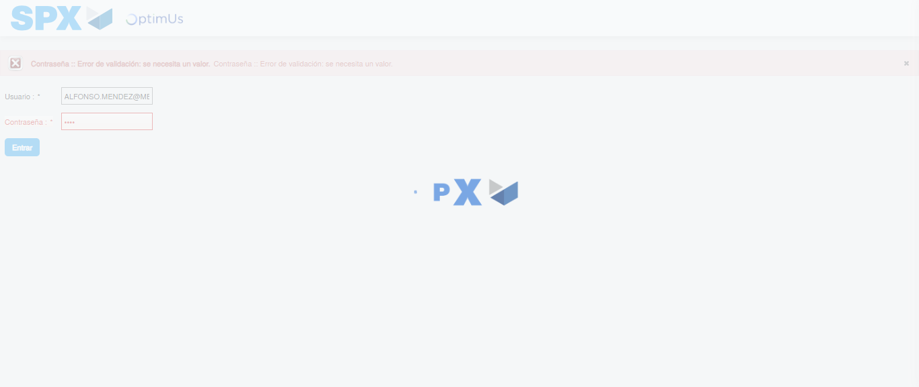Image file-name: QC_Testing-tc002_SPX_Dev5_Crear_Requisicion_Spot_Tipo_Cobro_Project-1783378232123

Step 2 - Select to UEN and Access to Spot Buy Requisitions : UEN Correctly selected and Correct access
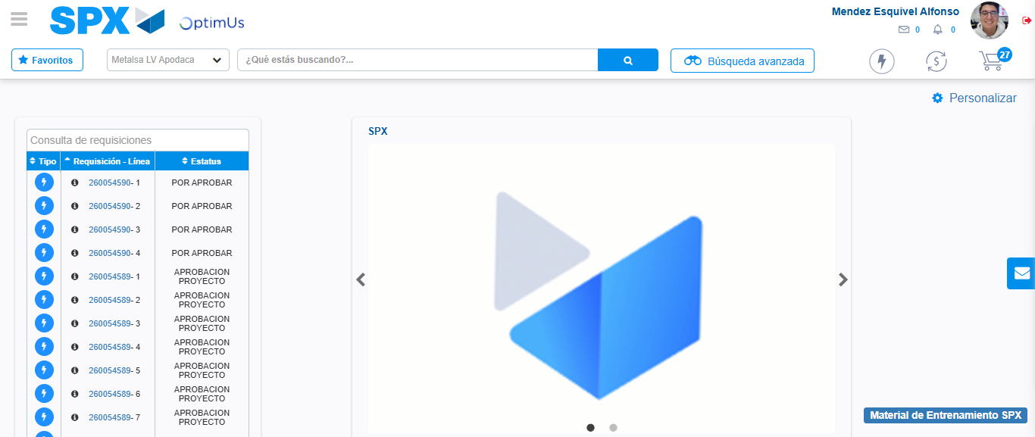Image file-name: QC_Testing-tc002_SPX_Dev5_Crear_Requisicion_Spot_Tipo_Cobro_Project-1783378257313

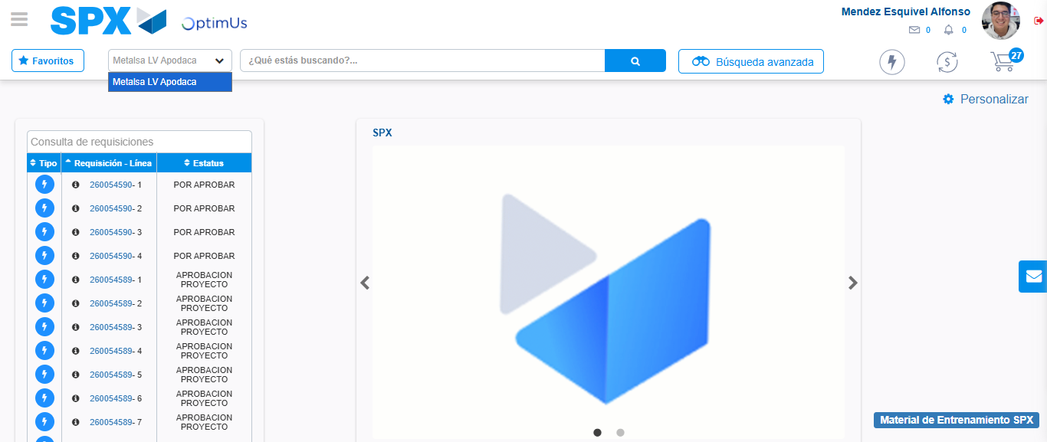Image file-name: QC_Testing-tc002_SPX_Dev5_Crear_Requisicion_Spot_Tipo_Cobro_Project-1783378259766

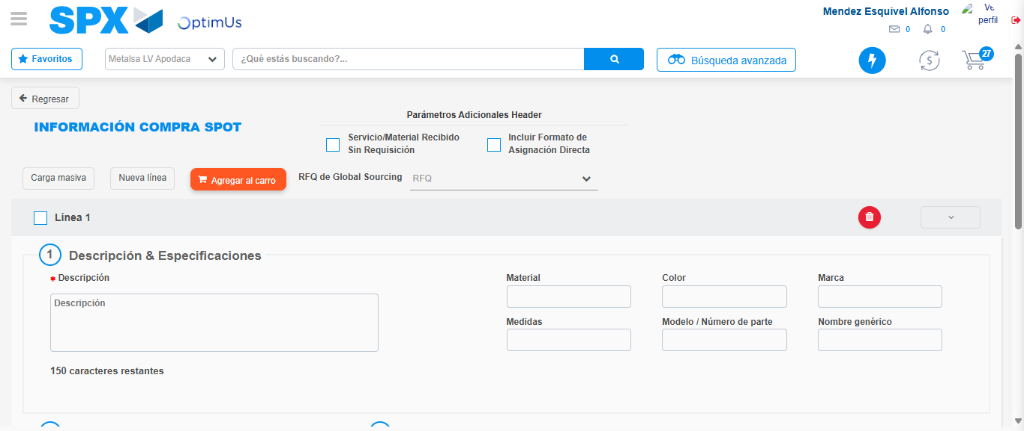Image file-name: QC_Testing-tc002_SPX_Dev5_Crear_Requisicion_Spot_Tipo_Cobro_Project-1783378284004

Step 3 - Data Capture Spot Buy Requisition: Data captured correctly
Image file-name: QC_Testing-tc002_SPX_Dev5_Crear_Requisicion_Spot_Tipo_Cobro_Project-1783378284220

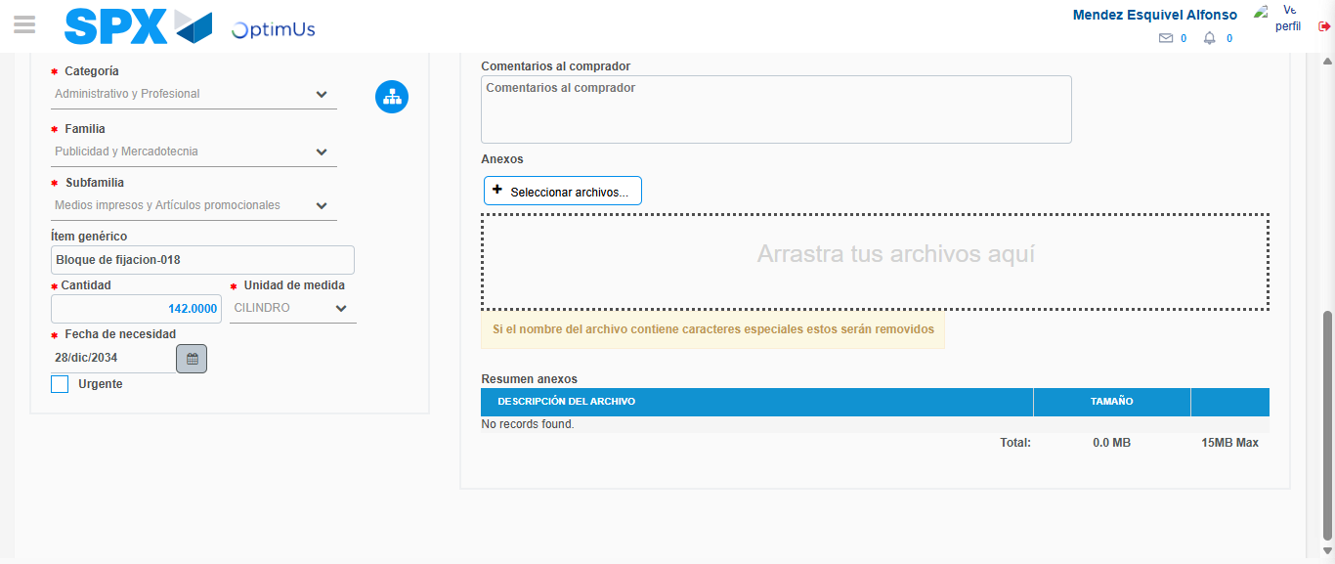Image file-name: QC_Testing-tc002_SPX_Dev5_Crear_Requisicion_Spot_Tipo_Cobro_Project-1783378294606

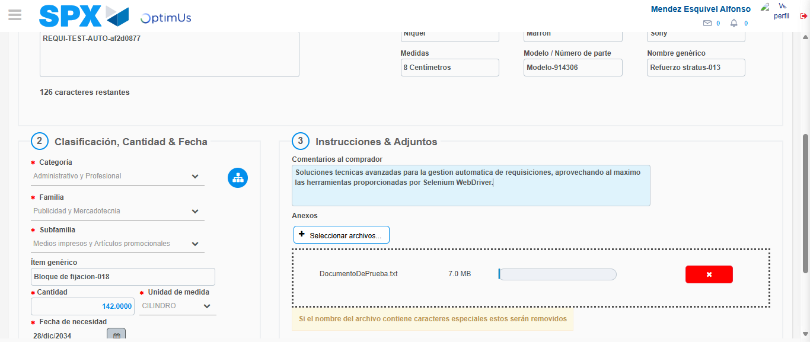Image file-name: QC_Testing-tc002_SPX_Dev5_Crear_Requisicion_Spot_Tipo_Cobro_Project-1783378295321

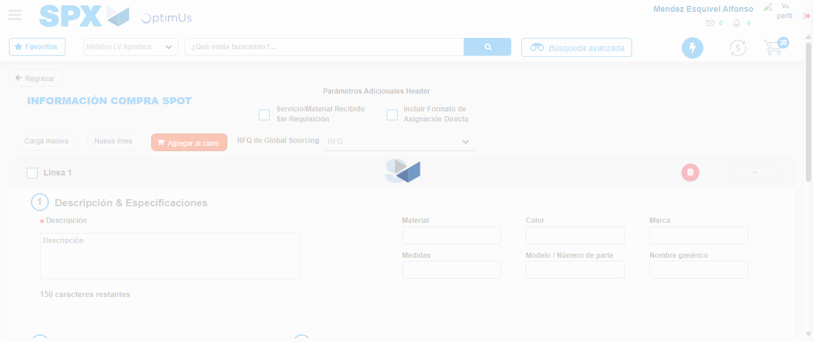Image file-name: QC_Testing-tc002_SPX_Dev5_Crear_Requisicion_Spot_Tipo_Cobro_Project-1783378299665

Step 7 - Return to Main Page SPX : Return to Main Page SPX
Image file-name: QC_Testing-tc002_SPX_Dev5_Crear_Requisicion_Spot_Tipo_Cobro_Project-1783378257313

Image file-name: QC_Testing-tc002_SPX_Dev5_Crear_Requisicion_Spot_Tipo_Cobro_Project-1783378259766

Image file-name: QC_Testing-tc002_SPX_Dev5_Crear_Requisicion_Spot_Tipo_Cobro_Project-1783378284004

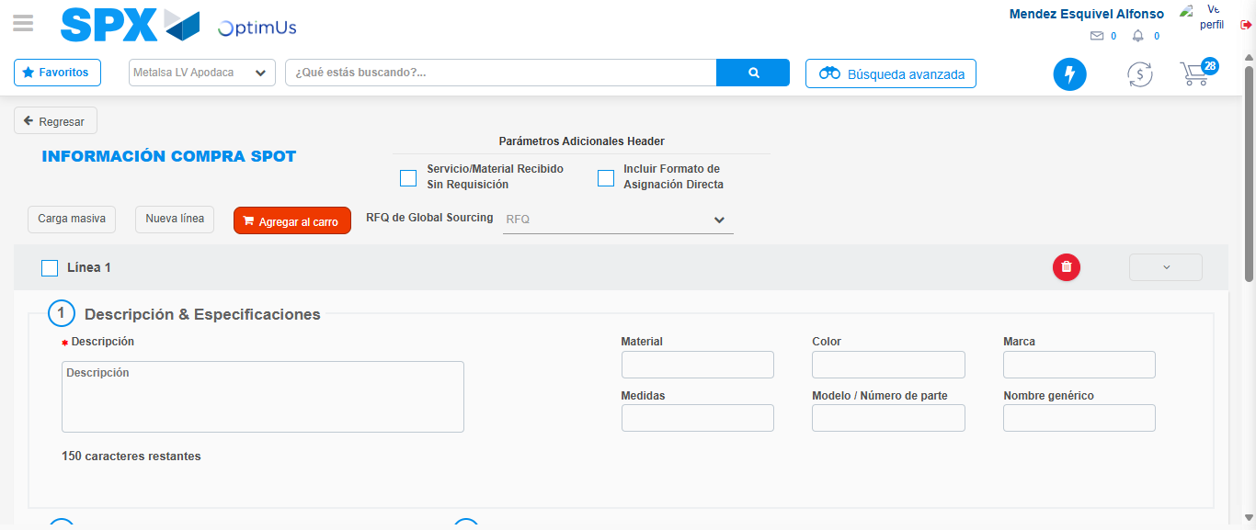Image file-name: QC_Testing-tc002_SPX_Dev5_Crear_Requisicion_Spot_Tipo_Cobro_Project-1783378301891

Image file-name: QC_Testing-tc002_SPX_Dev5_Crear_Requisicion_Spot_Tipo_Cobro_Project-1783378302035

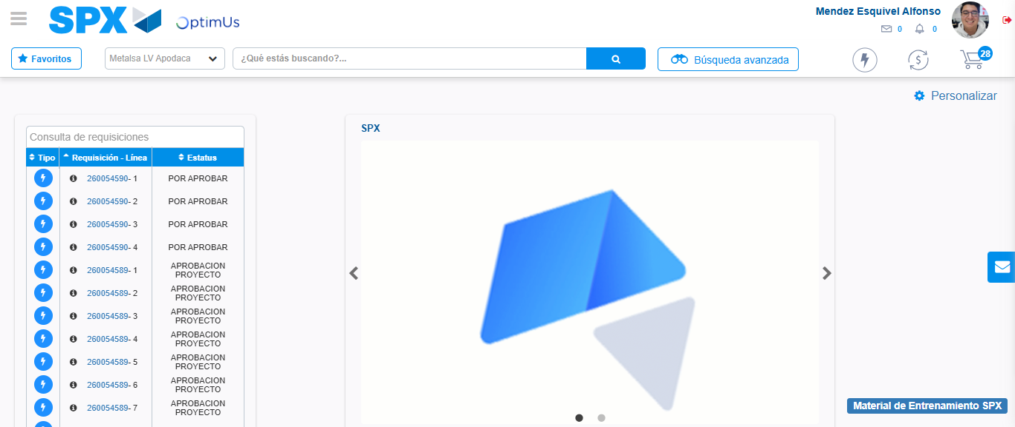Image file-name: QC_Testing-tc002_SPX_Dev5_Crear_Requisicion_Spot_Tipo_Cobro_Project-1783378322986

Step 8 - Log Out : Log Out SPX
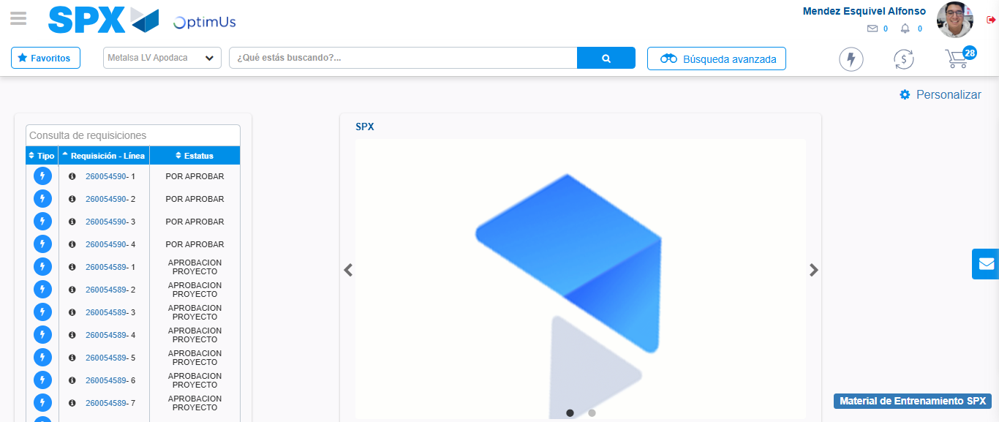Image file-name: QC_Testing-tc002_SPX_Dev5_Crear_Requisicion_Spot_Tipo_Cobro_Project-1783378323212

